DOCUMENTATION

**Group Members:**

|  |  |
| --- | --- |
| **Name** | **Sap ID** |
| Ahmed Ali | 55346 |
| Murtuza Ali | 54769 |

**Course:** System Design and Analysis  
**Class:** CS 4-2

**Riphah International University, Islamabad**

**Topic:** **Hostel Management System**

**Table of Contents**

1. **Overview**
   * A. Identified Issues
   * B. Proposed Approach
   * C. Key Functionalities
2. **Key Users and Their Needs**
   * A. Hostel Management Team
   * B. Wardens and Residential Staff
   * C. Students & Lodgers
   * D. Security Personnel
   * E. Technical & IT Support
3. **Requirement Gathering Methods**
   * Conducted Surveys
     + Open Responses
     + Fixed-Choice Questions
4. **Feature Prioritization Strategies**
   * Kano Model Analysis
   * MoSCoW Classification
5. **System Modeling (UML Diagrams)**
   * Use-Case Diagram – e.g., Room Reservation, Visitor Log, Issue Reporting
   * Class Diagram – Entities like Resident, Room, Request, Admin
   * Activity Diagram – Hostel Check-In Workflow
   * State Diagram – Room Condition Lifecycle
   * Collaboration Diagram – Interaction among Warden, Resident, and Admin
   * System Architecture – Layered Tech Stack for Hostel Operations
   * Sequence Diagram – Requesting a Maintenance Service
6. **User Feedback – Survey Data**
7. **Form Response Link**
8. **Code Repository (GitHub)**
9. Introduction:  
   The Hostel Management System is an online solution for managing student accommodations within university hostels. It automates processes like room allocation, fee payments, visitor logs, maintenance requests, and grievance tracking for students staying on campus.
10. Identified-Issue  
    Manually handling hostel registrations, allotments, and complaints leads to mismanagement, delays, and miscommunication. Students face difficulties in knowing room availability or submitting grievances, while hostel wardens struggle to maintain updated records and respond quickly to issues.

### Proposed Approach

With a Hostel Management System, students can apply for accommodation, check room status, pay hostel fees, and raise issues online. The warden can approve requests, track occupancy, and assign rooms digitally. Maintenance staff can get real-time requests, and reports can help monitor resources. This leads to a more organized, responsive, and transparent hostel environment.

### Key Functionalities

1. The Hostel Management System is designed to streamline and automate the full range of administrative and residential services within university hostels. Its core functionalities include digital room reservation and allocation, secure student registration, and an integrated payment module for hostel fees. The system also provides residents with tools to submit maintenance requests, log complaints, and track the status of their issues in real time. Wardens and hostel staff benefit from a centralized dashboard that allows them to monitor occupancy, manage approvals, and respond efficiently to student needs. Additional features such as visitor entry tracking, automated notifications, and analytics on facility usage contribute to a more transparent, organized, and responsive hostel environment. These functionalities work together to enhance the overall living experience for students while reducing administrative overhead.

## **System Stakeholders & Requirements**

## **A. Hostel Management Team**

## Oversee the overall functioning of hostel facilities and ensure adherence to institutional housing policies.

## Approve room allotments, fee structures, and visitor regulations.

## Review periodic reports on occupancy, complaints, and maintenance status.

## **B.** **Wardens and Residential Staff**

## Manage room assignments and oversee daily hostel operations.

## Address resident issues such as noise complaints, misconduct, or special accommodation needs.

## Monitor maintenance work and handle escalation of unresolved complaints.

## **C. Students & Lodgers**

## Submit applications for room allotment through an online portal.

## View available rooms, hostel guidelines, and status of their requests.

## Pay fees, lodge maintenance complaints, and track grievance resolutions digitally.

## **D. Security Personnel**

## Manage visitor logs, including entry/exit approvals and ID verification.

## Ensure that only authorized individuals access hostel premises.

## Respond to emergency alerts and report any security breaches.

## **E. Technical and IT support**

## Maintain the uptime and security of the hostel management system.

## Implement role-based access controls for wardens, students, and admins.

## Provide technical support to users and ensure data backup and protection.

## 3. Elicitation Techniques Applied

### **Interviews: Conducted with hostel wardens, students, and maintenance staff.**

### **Surveys: Distributed among students and administration to gather feedback on hostel facilities and issues.**

### **Observations: Daily operations of hostel routines and room allocations were monitored.**

### **Workshops: Held brainstorming sessions to improve hostel living conditions and digital record management.**

### Survey Questions

* **Open-Ended Questions:**
* What challenges do you commonly experience with your hostel accommodation?
* In your opinion, how can the current system for allocating hostel rooms be improved?
* Have you encountered any problems regarding hostel fee payments or dues management? Please elaborate.
* Can you describe a recent maintenance issue you faced and how it was addressed by the management?
* What features or functionalities would you like to see integrated into a digital Hostel Management System?
* What measures could improve communication between hostel authorities and residents?
* Have you ever experienced difficulties during the hostel check-in or check-out process? Please describe.
* What recommendations would you make to enhance safety and visitor tracking in the hostel?
* How do you think the dining/mess services could benefit from automation or digital management?
* Please share your experience with the complaint submission process and the response time from hostel staff.
* **Closed-Ended Questions (Rephrased):**
* Have you experienced delays in response to maintenance or repair requests?
* Yes / No
* Do you feel the hostel’s security measures (e.g., guards, surveillance, visitor logging) are adequate?
* Yes / No
* How regularly are you informed about important hostel notices or updates?
* Always / Often / Sometimes / Rarely / Never
* Do you think implementing a digital Hostel Management System would enhance your overall hostel experience?
* Yes / No
* Would you prefer making hostel fee payments through an online platform rather than manually?
* Yes / No

## 4. Prioritizing Techniques

### A. **Kano Model**

### **What is the Kano Model?**

### The **Kano Model** is a prioritization framework that categorizes system features based on **how they affect user satisfaction**. It helps distinguish between **must-haves**, **performance features**, and **delighters**, giving a deeper view into what really impacts user experience.

| **Feature** | **Stakeholders** | **Category** | **Description** |
| --- | --- | --- | --- |
| **Online Room Booking** | Students | Must-Have | Essential for managing allocations without manual hassle. |
| **Issue Reporting System (Maintenance)** | Students, Wardens | Performance Need | The quicker it's resolved, the more satisfied the users. |
| **Visitor Entry Logging & Approvals** | Security, Admin | Must-Have | Core for safety and compliance. |
| **Complaint Tracking & Escalation** | Students, Admin | Performance Need | Impacts resident comfort and admin responsiveness. |
| **Automatic Bill Calculation & Payment Portal** | Admin, Students | Performance Need | Boosts efficiency and user trust. |
| **Roommate Preference Matching** | Students | Exciter / Delighter | Not expected, but highly appreciated when present. |
| **Mobile App Notifications (curfews, cleaning, alerts)** | Students | Delighter | Adds convenience but not a deal-breaker if absent. |
| **Emergency Alert System** | All Users | Must-Have | Crucial for health/safety protocols and urgent notices. |

### **Why It's Better for Hostels??**

### Hostel users include both **administrators and live-in students**, who care about comfort, responsiveness, and safety.

### Kano helps you **avoid overinvesting** in features people don’t care about while making sure you cover expectations.

### It considers **emotions and user delight**, which is central in living environments.

### B. MoSCOW Technique:

| **Priority** | **Requirement** |
| --- | --- |
| **Must Have** | - Student registration and login module- Online room application and allocation system- Digital fee payment gateway integration- Real-time grievance submission and tracking- Warden dashboard for approvals and monitoring |
| **Should Have** | - Visitor entry logging and approval- Maintenance request submission and tracking- Automated email/SMS notifications for key updates- Room availability calendar with filters- Student profile and history (stay record, past requests)- Analytics for hostel occupancy and maintenance trends |
| **Could Have** | - Mobile application for easier access- Biometric or QR-based check-in/check-out system- Integration with academic portal for verification- Feedback mechanism for facilities and staff |
| **Won’t Have** | - AI-based predictive allocation- Voice-assistant enabled service requests- IoT-based room monitoring (temperature, lighting, etc.) |

## 5. UML Diagrams

1) Sequence Diagram

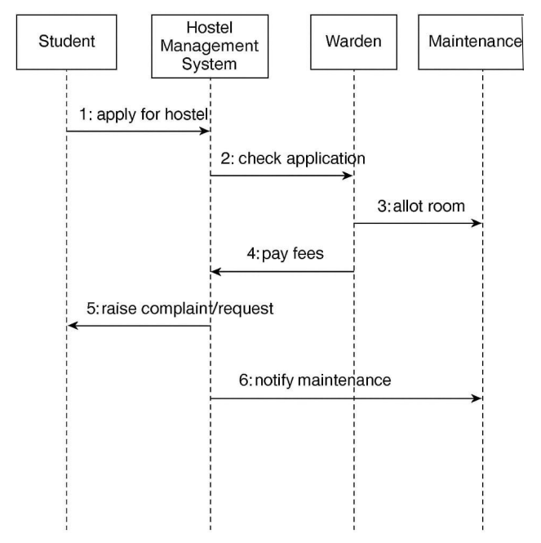

2) State Diagram

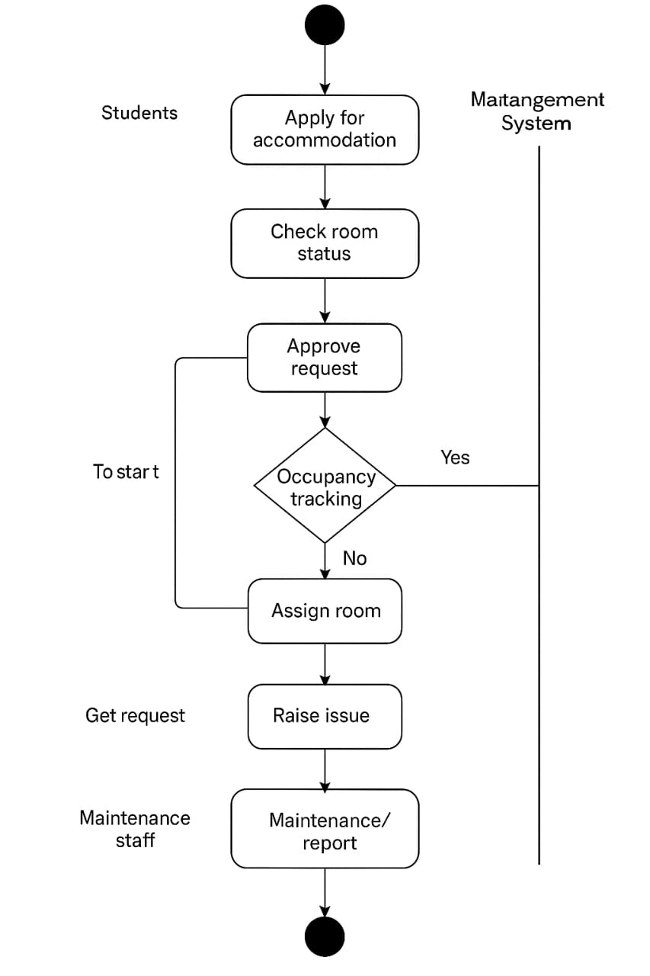

3) Use Case Diagram

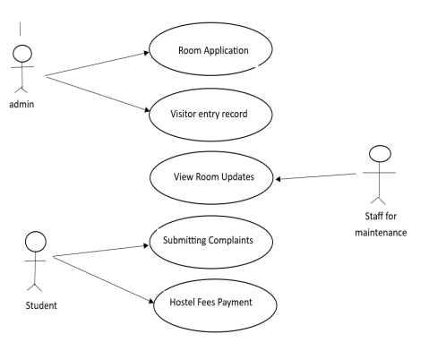

4) Activity Diagram



5) Architecture Diagram

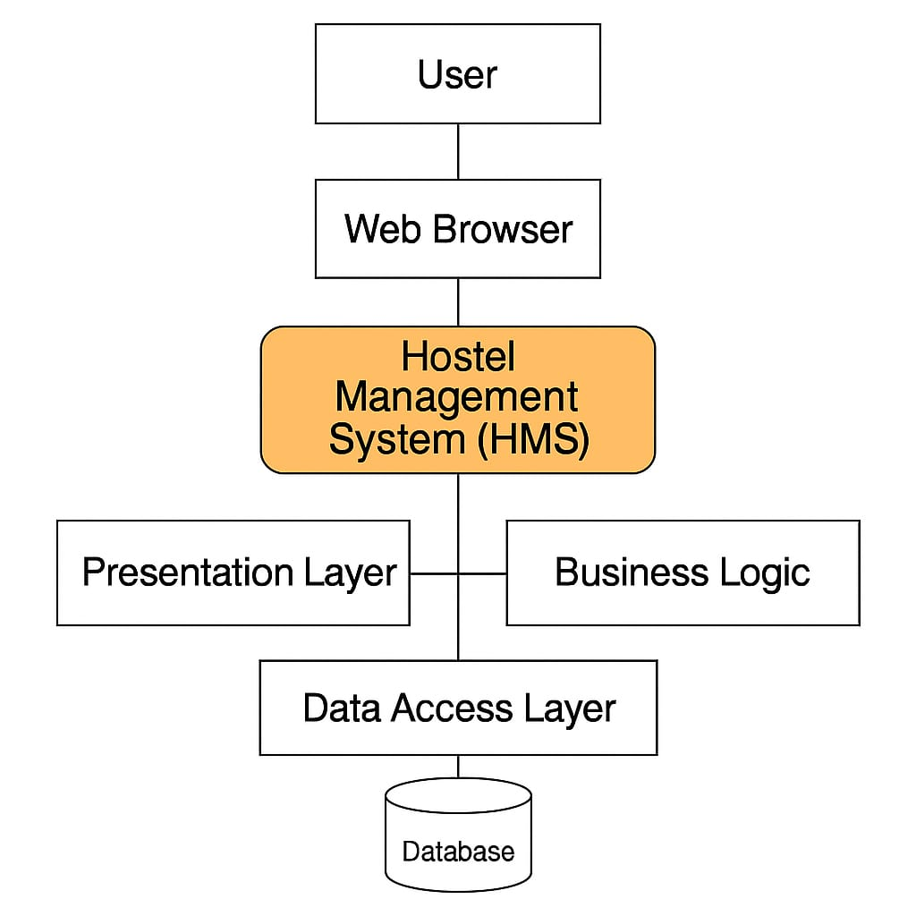

6) Collaboration Diagram

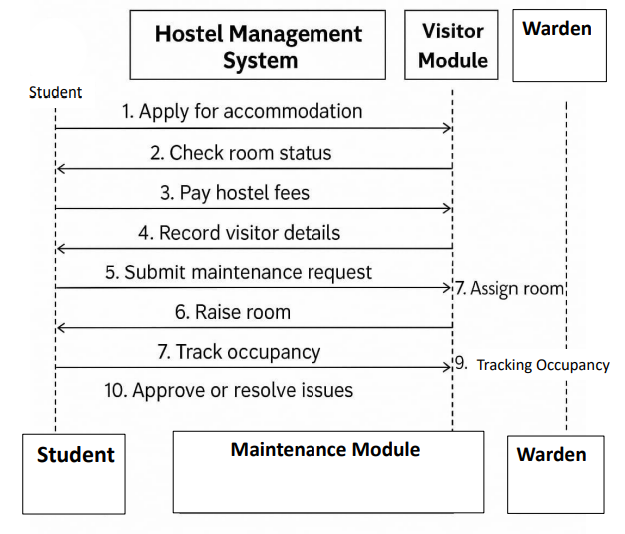

7) Class Diagram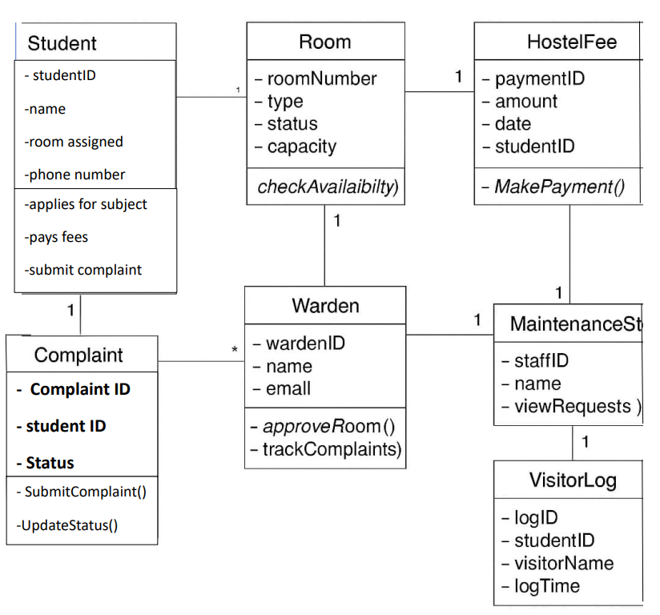

Survey Questions (Responses)   
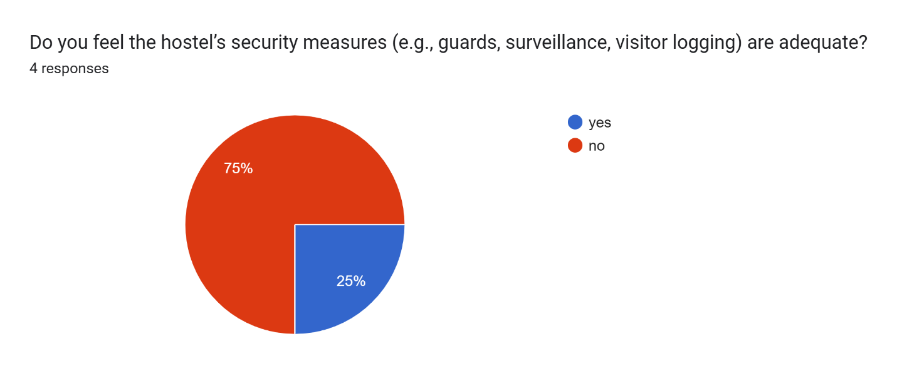

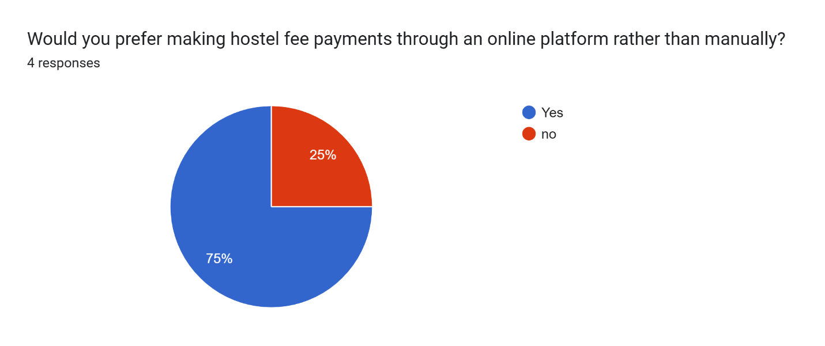

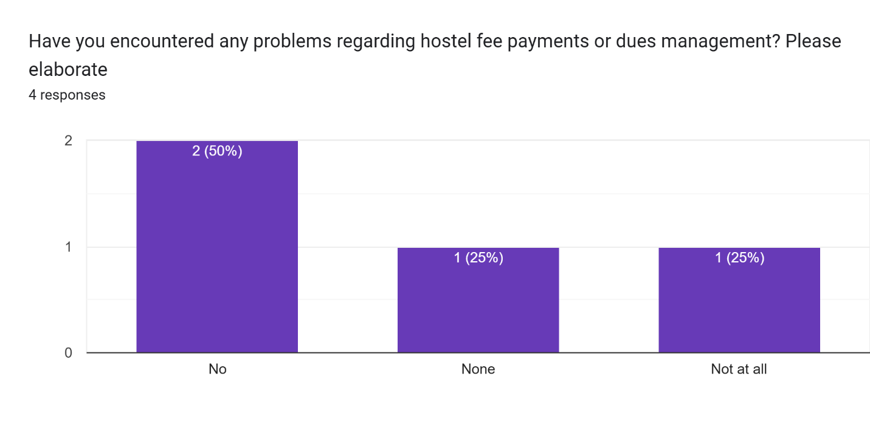

# GitHub Repo Link

<https://github.com/Ahmedali55346/System-Analysis-and-Design.git>

# Survey(google forms) Link

https://docs.google.com/forms/d/e/1FAIpQLSdLkoD_oPzNEy994OyjyOeB2-sT0JbxOC1Tu-MDJBHByb47xA/viewform?usp=header